**THE ARCHDEACONRY OF BLACKBURN**

**DEANERY OF BLACKBURN WITH DARWEN**

**(NB This notice should be displayed prominently on the church notice board on the next Sunday after receiving it)**

To the **Churchwardens**

**(NB This notice should be displayed prominently on the church notice board on the next Sunday after receiving it)**

To the **Churchwardens**

I hereby give notice that you are requested to attend the **Visitation** for the Admission of Churchwardens to be held at **Oswaldtwistle Immanuel on 14 June 2023 at 7.30 pm.**

It is essential that those who have been elected to serve as Churchwardens for the year 2023-2024 should be present on this occasion, having first been elected to office by due process.

A form of nomination for Churchwardens, with details of how nominations should be made, together with details of those who are excluded from election, are provided on the Diocesan website, [www.blackburn.anglican.org/Archdeacons](http://www.blackburn.anglican.org/Archdeacons) pages. Please print this notice as appropriate.

If you are unable to attend this visitation, please advise [gillian.beeley@blackburn.anglican.org](mailto:gillian.beeley@blackburn.anglican.org) or [Kelly.quinn@blackburn.anglican.org](mailto:Kelly.quinn@blackburn.anglican.org)

31 March 2023

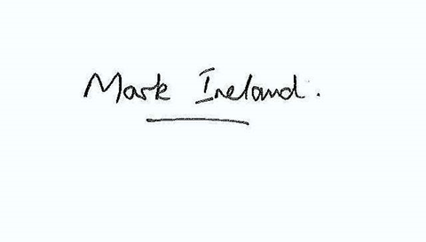Ven Mark Ireland

Archdeacon of Blackburn